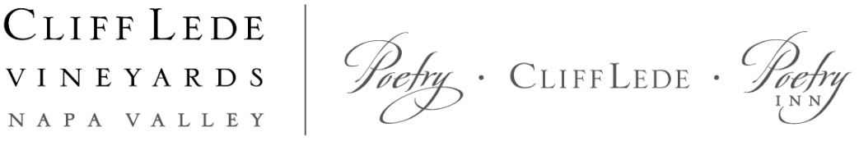

2014 Cliff Lede Cabernet Sauvignon, Howell Mountain

Vintage
The 2014 vintage was a vintner’s dream. A dry late winter with unseasonably warm temperatures prompted an early bud break, leading to one of the earliest harvests on record. Moderate weather throughout the spring and summer allowed the vines to achieve a good set. The dry soil conditions led to low-vigor vines and small, abundant berries, creating very concentrated fruit that ripened with the warm fall days. With lovely autumn weather, harvest proceeded at a steady pace.

Vineyards
Exceptional high-elevation vineyards in the Howell Mountain appellation produce intensely concentrated grapes for this wine. Soils are volcanic in origin and consist of two main types; the first is decomposed volcanic ash called tufa, and the second is red volcanic rock and clay that is high in iron. Both are nutrient poor, which stresses the vines, producing intense and structured wines from small clusters and berries. The altitude, climate, and soils combine to create a classic mountain Cabernet Sauvignon with incredible concentration, texture, and structure.

Winemaking
Hand harvested in the cool early morning hours, the fruit was immediately subjected to rigorous selection by our three-tiered sorting process, including our cutting edge optical sorter, with a goal of eliminating less-than-perfect berries. The selected fruit was gently delivered to tank via gravity by our crane system, retaining perfect, whole berries. Cold soaks lasted approximately five days, and fermentations were managed by a combination of délestage and pump overs. Extended maceration, ranging from three to four weeks, fine-tuned tannin profiles, allowing us to build structure and wine complexity. The wine was aged in French oak barrels, 60% of which were new, for twenty-one months.

Winemaker Notes
There is an unrelenting quality to the powerful, young 2014 Howell Mountain Cabernet Sauvignon. The distinctive flourish of aromas is so reminiscent of the mountain volcanic soil and pine forest terrior where it is grown, that it could be from nowhere else. Sous bois aromas comingle with warm dark chocolate, iron, burning incense, and juniper notes. There is plenty of blackberry, cassis, and black licorice on display, accented with heady fresh mint, lavender, and clove. Almost impenetrable now, this wine has a long life ahead, so it requires some patience. If your curiosity gets the better of you, give this wine some time in the decanter before enjoying. -Christopher Tynan, Winemaker

Composition: 97% Cabernet Sauvignon, 2% Merlot, 1% Petit Verdot
Alcohol: 14.3%
Bottling Date: July 2016
Release Date: October 2017
Production: 580 cases

